A6 - I’ m special, you’re special!

Activity
We make the album/book of the class.
Content
Students make an album with their names, portraits, preferences and they talk about themselves.
Language objectives
- To revise vocabulary related to age, preferences and greetings, e.g. Good morning!/ Hello!/ Hi, I’m … Maria./ I’m seven years old./ I like bananas/hamburgers.
- To revise food vocabulary which is similar in English and Greek, e.g. bananas, carrots, hamburgers, biscuits
- To recognize greetings in written English
- To revise the plural of regular nouns
Pedagogical objectives
- To develop their fine motor skills, e.g. colouring
- To have fun making their class album
- To raise their awareness of their uniqueness within the context of a group, i.e. their class

Materials and equipment
Materials:
- Pictures of food (B_A06_F01, B_A06_F02, B_A06_F03, B_A06_F04, B_A06_F05, B_A06_F06)
- Sheets of paper (Α4-sized)
- Color pencils or markers
- A hole puncher
- Threads or ribbon
- A photo of the students
- CD (Β_Α06_Μ01)
Equipment:
- CD player and/or P/C
Worksheet: B_A06_W01
Suggested online material:
- Songs:
http://www.preschooleducation.com/sme.shtml
Suggested time: 2 teaching hours

Suggested procedure
Step 1 We walk into the class holding the mascot and a small ball. We all form a circle, the mascot greets the children telling them his/her name and age, and then throws the ball to a student asking him/her to do the same. For example:
- Hello. I’m Mary and I’m seven.
When all students have introduced themselves, we ask them to sit down.
Step 2 Then, we show them pictures of food, the names of which are common/similar in English and Greek, such as hamburgers, bananas, carrots, biscuits (B_A06_F01, B_A06_F02, B_A06_F03, B_A06_F04, B_A06_F05, B_A06_F06). We stick them on the board and we say: ‘I like bananas’ and we encourage students to produce their own sentences as we show them the pictures, e.g. when the teacher sticks the banana picture on the wall, he/she says:
- Hello! I’m Maria. I’m 7 and I like bananas.
We can also present the new vocabulary through questions. The teacher can cover the flashcard with his/her hand and then start revealing it little by little asking the students: What’s this? Is it an orange?
Step 3 We give children the worksheet (B_A06_W01) and tell them that we are going to make the album of our class. We explain that there is the outline of a face on their worksheet based on which they should draw their own faces. We write their names in faint writing and later, students will have to ‘trace’ them with their markers. On the second line, they are going to write their age (just the number) and they are going to draw their favourite food in the bubble. We move around the class and help those who need help either with their drawing or with the tracing.

Step 4 When all students have finished, we collect all the worksheets and make holes on them with the hole puncher. We add a blank page as a cover and we stick a picture of the students on it writing ‘Our English Class B1/ Β2’, etc. Then, we tie the worksheets all together with some thread or ribbon.

Step 5 When we have finished making the album, we present it to the children saying: ‘This is our class book’. Then, we ask each student to “read” their worksheet. We can even make one page for ourselves and include it in the album. As we browse through the album, we tell children that all people are different and unique but that we are all friends with each other and that we belong to the same group, that is our class.

Step 6 Then, we explain that we are going to learn a song about how special each person is. We start singing the song ‘I am special’ (Β_Α06_Μ01, lyrics) and then we repeat the procedure along with the children. Children can stand up, one at a time, as we sing the song, pointing at themselves.

Educational material
(Click on the archives to download them)

Pictures
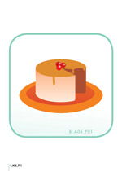 | 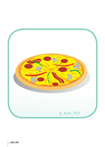 | 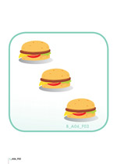 | 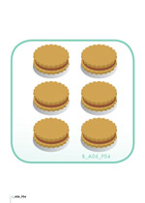 | 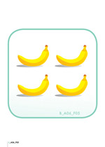
B_A06_F01 | B_A06_F02 | B_A06_F03 | B_A06_F04 | B_A06_F05

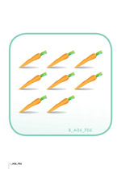 | 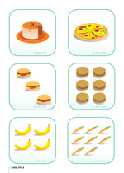
B_A06_F06 | B_A06_F01-6

Worksheet
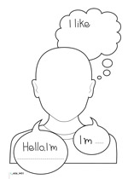
B_A06_W01

Audio material
- Β_Α06_Μ01: I AM SPECIAL

Lyrics
I AM SPECIAL
I am special,
I am special,
Look at me,
Look at me.
A very special person,
A very special person
That is me,
That is me.
(X2)

